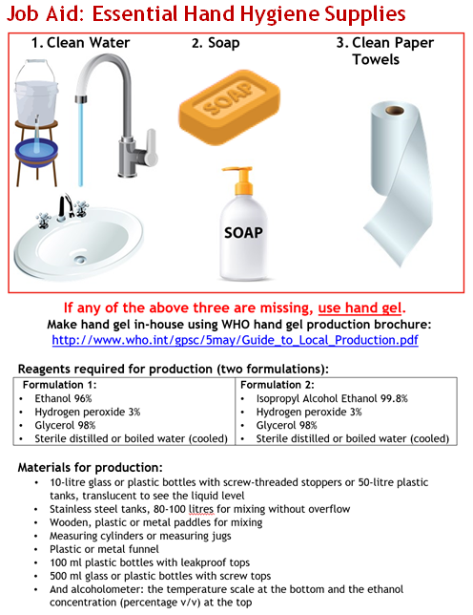
See the World Health Organization brochure for full directions

